– Draft Agenda –
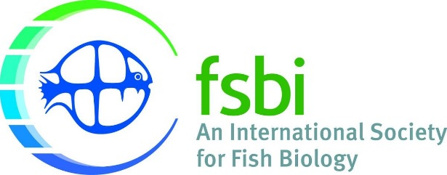
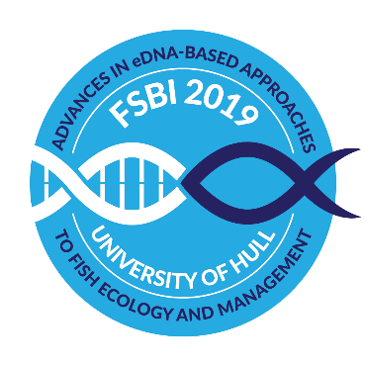

FSBI 2019, 15th – 19th July, University of Hull – Canham Turner Building

Da | Monday | Tuesday | Wednesday | Thursday | Friday
9 | Arrival | Welcome address  Jack Jones Lecture:  Chris Jerde | Keynote Elise Furlan  Session 4:  Invasive Species | Keynote Masaki Miya  Session 6:  Marine Ecology and Fisheries | Keynote Didier Pont  Session 8:  Monitoring and Application to Policies
 |  | Coffee
11 |  | Session 1:  Freshwater Ecology and Conservation | Session 4 continued | Session 6 continued | Session 8 continued
 |  |  | FSBI - Annual General Meeting |  | Closing address and student prizes
 | From 13:00  Registration  + Poster set-up | Lunch
14 |  | Keynote Kirsty Deiner Session 2:  Ecology of eDNA | Keynote Alice Valentini  Session 5:  Freshwater Ecology and Conservation | Keynote Michael Traugott  Session 7:  Molecular Foodwebs | 14:00 conference closes
 |  | Coffee
16 |  | Session 3:  Methodological Advances | Session 5 continued | Session 8:  Fish Health and Pathogens
after 19 | Wine reception | Dinner | BBQ | Conference Banquet

